Our Arrival in Heaven
July 21, 2026
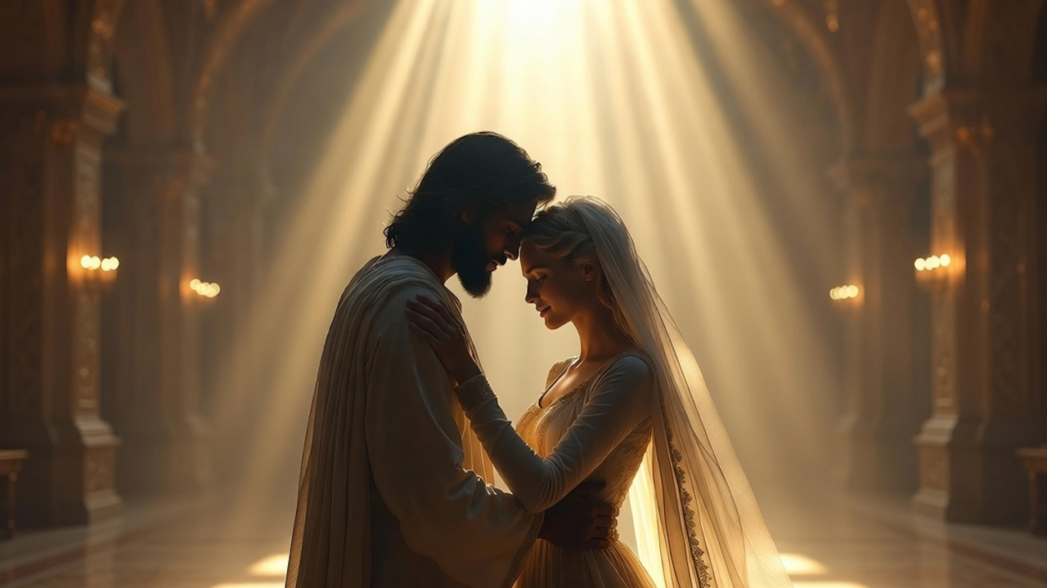
Lord Jesus, thank You for this sweet break from all the tragedy in this world. May all Heartdwellers find encouragement and hope in what You’ve prepared for those who love You. Amen.
Wow, I asked the Lord what was on His heart tonight and He gave me a very uncharacteristic answer. He said,
“Well, I’ve been thinking about the ballroom and how joyfully we dance together. My brides, this time when we are together is so very special to Me. This is a time when I want to be with you for the sheer joy you bring Me.
I know you’re tired of hearing it, but soon, very soon, this ballroom will become your reality as we celebrate the victory over darkness, over self-hatred, condemnation, and all the sludge the enemy works so hard to cover you in. It will be My extreme joy to welcome you to the dance floor in specially designed clothing that shimmers in gratitude and to see your lovely hearts totally released from the nightmare that has ruled this earth for so very long.
I rejoice to clothe you in the most beautiful flowing garments of celebration with touches of gold and precious stones, highlighting and adorning your precious forms. I have saved and collected the finest jewels for that day. You will be arrayed in silk and satin; in colors you’ve never seen before. In heaven, jewels form in the atmosphere of jubilation and unfettered joy.
So many await your arrival and anticipate the wondrous colors, the textures that have been set aside for our special day. Yes, your clothing in heaven has special meanings, just as it does on earth, and I have carefully chosen the things that most suit you.
Not one part of your transformed bodies will have pain, not one malfunction, lameness, brokenness, or deformed limbs. Everything will be restored to pristine newness and purity. This coming about through the healing you will feel in heaven that will completely erase the effects of sin that were so prevalent on earth.
Your joy will know no boundaries. It will ring out in the halls of heaven as you finally comprehend you’ve been translated from death and the grave to eternal happiness with Me. Many friends and relatives you never expected to see again will greet you transformed, forgiven, cleansed, and endowed with new skills and endless joy.
Right now you cannot imagine what it will feel like to be free from the gross darkness you have lived under your whole life. You’ve never known what it feels like to be free from faults and condemnation. As you are filled with joy unspeakable, all the parts of your mind and body will be liberated from this death sentence.
My lovely ones, when you behold your transformed bodies you will be breathless. Yes, it will literally take away your breath. You will feel such joy when you behold the beauty of others that surround you as they too are overcome with feelings of joyful reunion, free from the dark memories and the sorrows of their past.
There will not be any hint of rejection or criticism. You will be embraced by all souls in heaven and be completely free from feelings of judgment, rejection, or being judged. Instead, you will be inundated in supreme bliss and freedom which you have never before experienced.
You will not have to try and fit in or be accepted. Rather, the rush of love that propels those around you will overcome you before you can even think of or understand what’s happening to you. My love will gush forth from every person you encounter and you won’t even have time to recognize what is happening to you.
Your eyes will behold beauty and glory everywhere they look. You will not come to heaven; rather, heaven will engulf you and overwhelm your senses. The lakes and rivers and mountains and the trees, the tiny grains of sand, every leaf of even the tiniest plant will overwhelm you with its lacy intricacy, and the very ground you walk on will reflect shimmering rainbows from vibrant crystals scattered around.
The fragrances will inebriate you as you melt right into them. So very profound will the feelings of unity with this creation be. Everything will vibrate rejoicing, and that feeling will overtake you as if you had been immersed in a warm and fragrant pool of bliss. Everything you encounter will rush to embrace you.
Clare, music will cause your body to be more and more unified with every living thing and draw you into the most profound inner peace that you have ever known, for truly peace reigns in heaven. There will be nothing to frighten or disturb you, no harsh sounds or violent movements, for everything vibrates with the knowledge of My love and is in a continual state of thanksgiving and celebration.
Beloved, right now in this moment I cannot convey to you the complete happiness and contentment you will experience through every vibrant living thing. I cannot convey this to you in words. There are no words—only infinite bliss and security where all around you is inebriated in complete heavenly joy forever and ever.
This will be your reward after the long and dark trials of earth, and you will know love unspeakable as together we celebrate your homecoming.”

